Augmented Reality(AR)

**What does it do?**

Many people believe that virtual reality and augmented reality are the same, but they are wrong. In virtual reality the person experiences a stimulated world and in augmented reality the person experiences computer generated information that enhance reality, such as sounds, videos and graphics. AR, even though sounds futuristic, has been around for years. Augmented reality as a term started from 1990. Nowadays, because of the rapid development in technology, people have started to use AR more. Many use AR every day without even knowing, for example snapchat and Instagram filters. Also augmented reality is very well known in gaming. A very popular game named “Pokemon GO” released by Niantic, is based on AR. Soon, because of the rapid development in technology, AR will improve even more. It will be used frequently to improve and make life easier. People will use AR for many reasons, like writing something on a board that will pop up on the wall using your mobile phone or even wearing some type of special glasses that will help you see a movie on the wall just like a projector. Another example is industrial design. Companies that sell furniture can develop an app that lets you place the furniture in your house with augmented reality to check the dimensions of the furniture and also see if you like the colour.

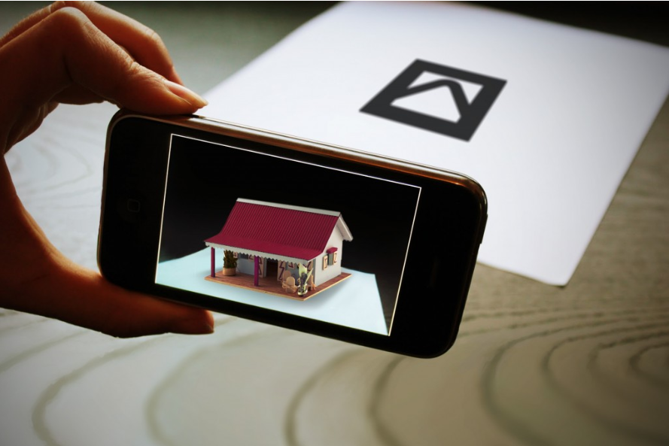

Eventually AR will be used even in education, there can be interactive boards accessed with a mobile phone or with some special glasses, for maths physics or chemistry. AR could be used in healthcare aswell. For example in diagnosing and monitoring patients. Another way it can be used is in military for advance navigation and marking objects in real life saving them time and making things easier. Also AR could be used in art, for example visual paintings and music.

In order for all of these to happen there has to be some sort of device that will let the user interact with AR. This can be achieved with mobile devices and AR glasses also called smart glasses. These devices are already being used. For example most of the people have a mobile phone or a tablet. Many smartglasses have been released such as Google Glass but still there is a lot of improvement that needs to be done. Companies are also working on making smart lenses taking augmented reality one step even further. Manufacturers like Samsung and Sony are working in the development of AR lenses. Another project that is being developed is Virtual Retinal Displays(VRD) which will create bright and high resolution images by projecting laser light into the human eye. Gaming could also change a lot and take it to another step with AR and let the user interact with the game even more.

**What is the likely impact?**

In the near future things will start to drastically change with technology. AR will be used almost everywhere. It will make life easier for everyone. People will be able to use AR on a daily basis even in their jobs. It will help people be more efficient on what their doing. For example if someone wants to save something by writing it on a piece of paper it would be easier for him to use AR and just write it on a paper that will pop up on his wall using his mobile phone or smart glasses, and then save it. Then if he one day wants to see what he has written on that paper he could just check his saved files rather than looking to find a paper. This technology will affect the younger generation more since they are the ones who use technology more. It will be hard for older people to get used to AR and learn how to use it. In my opinion, I don’t belive that AR is going to replace people in any job but instead create new jobs. People who will be able to create or use any AR apps will be very demanding from big manifacturers.

**How will it affect you?**

In my daily life AR will affect me in a positive way. Since I like technology and I find interesting learning new things, AR will be great for me. I have always seen on movies and videos people using AR or some type of holograph and I always found that astonishing. It would be very nice if I could just talk to my friends or someone in my family with a holograph and feel like they are in the same room with me. Just by wearing smart glasses I will be able to pop up a list infront of me and see my to do list. Also I believe it will affect my family and my friends in a positive way too. It will help them all in different ways. They will be able to watch videos or check the news while doing something else just by wearing some special machine on their heads. They will also be able to play games based on AR or call someone and their face will float infront of them while they have gone for a walk, just like the movies. As the time goes by, im sure AR will improve rapidly and new features will come out.AR will change a lot of things and also the way people live. It will make life easier and also help many people be more eficient in their jobs.